|  |
| --- |
| Your Cystic Fibrosis App |
| Research   Name: Lorcan BerminghamStudent Number: C00196903November 6, 2017 |

### Tutor: Dr Joseph Keogh

Contents

Abstract 4

Background 4

Lungs 4

Digestive System 4

Risk Factors 5

Aim 5

Why 5

Medical Information 6

Email 6

Questions 7

Breakdown 9

What will be measured? 10

How will it be measured? 11

Applications 11

Food Diaries 11

Motion Applications 17

What is a spirometer 19

Why use one 19

Arduino 20

What is it 20

What is it used for 20

What and why will I use it for 20

Sensors 20

Arduino sensors 20

Mobile Sensors 22

Creating a Spirometer 23

Materials 24

Step 1 construct spirometer tube 24

Step 2 select pressure sensor 24

Step 3 Attach Arduino Uno microcontroller 25

Step 4 Configuration 25

Step 5 27

Why I didn’t make a spirometer 28

Spirometers 28

Platforms 30

Android 30

IOS 31

Web Applications 32

Native v Web Application 33

Native applications 33

Web Applications 34

Development Tools 35

Android studio 35

Ionic 2 38

Technologies 39

Backend 39

Databases 40

Security 44

Mobile 44

Cloud 44

Conclusion 45

Appendices 46

References 49

## Abstract

The application is aimed at children with cystic fibrosis in Ireland between the ages of 12 to 18 and their doctors. The reason this age range has been selected is because intervention through these years can lead to better outcomes for the patient's overall health.

Now a CF patient between the selected age range will only see their team of doctors every three months. The only exception for this is if they are very ill as there is a shortage of suites that can accommodate patients with CF.

## Background

Cystic Fibrosis is an inherited chronic disease that primarily affects the lungs and digestive system.

### Lungs

A defective gene causes the body to produce thick, sticky mucus. This over time damages the lungs blocks airways making it hard to breathe. (see Appendix A)

#### The most common symptoms of CF respiratory are

* Chronic coughing
* Recurring chest cold
* Wheezing
* Shortness of breath
* Frequent sinus infections
* Allergies that last all year

Symptoms of the lung disease start from infancy and there is all small but progressive loss of lung function with every passing year.

### Digestive System

The CF gene obstructs the pancreas and stops the natural enzymes from helping the body break down and absorbing food. (see Appendix B)

#### The most common symptoms of CF gastrointestinal disease are

* Inability to gain weight which can potentially lead to the patient having to take extreme measures such as been tube fed or peg fed
* Diabetes because of high blood sugars and some of the medicines over time can lead to a patient contracting diabetes
* Poor growth
* Excessive sweating
* Recurrent inflammation of the pancreas
* Salty skin

### Risk Factors

#### Genes

CF gene mutations are divided into three classes 1,2,3 are generally more severe causing "Classic CF", classes 4,5 are usually milder. Also, other genes called modifier gene can affect a person's symptoms and outcomes.

#### Environments & lifestyles

People with CF have to consume a very large number of calories to maintain weight and grow which can be difficult to achieve. Physical activity is also important to help keep lungs healthy.

#### Age

Age plays a large role in a patient's life. There is specific age ranges throughout a patient's life that can have a big or small impact on a patient's quality of life.

#### What causes CF

CF is caused by having two abnormal copies of the CF gene. CF cannot be caught or acquired. It can occur in people who have no known family history of the disease, both the father and mother must have the abnormal gene and they have a 1 in 4 chances of having a child with CF. If a couple has a child with CF than the rate changes to a 50/50 chance.

### Aim

The aim of this application is to target a specific CF age range (12 to 18) to monitor the physical activity and dietary progress they make through the 3-month period between the patient's scheduled doctor’s appointments.

### Why

The information that could be gathered from the 3-month interval could provide a team of doctors with specific information that could help optimize the patient's treatment plans based on the data recovered.

The food diary would help build an accurate picture of the patients eating habits over the period and keep track of calories. It would help a dietician build a complete food plan for the patient.

## Medical Information

### Email

To whom it may concern,

My name is Lorcan Bermingham and I am studying at Carlow Institute of Technology. I am currently in my fourth year of software development.

I am developing an application that will target patients with Cystic Fibrosis. I will be looking at a specific age range 12 to 18. The application will monitor two specific areas, the first will be physical activity and the second will be eating habits. This data will be monitored between doctor appointments.

The aim of this application is to give a patient’s team of doctors the ability to get a complete overview of their patient's health throughout the period since their last appointment.

The reason that I have chosen that age range as my sister Rachel has CF and through her early years (12 to 16) she was relatively healthy and would only see her doctors in Crumlin every 3 months. Once she turned 17 though that changed and she began to slip and had to go into hospital more and more but there was no definitive reason why. I know that every patient with CF is different and have their own individual symptoms.

I hope that this application will be able to give a team of doctors more information from the patient when they are healthy straight through to when and if they begin to decline. The application will monitor how active the patient is, including any sports groups they are part of and I will be using a food diary to monitor eating habits. All of this data then will be displayed to that patient's doctor for them to review.

Application Main Points

* Patient Activity
  + Motion sensor
  + sport tracker
  + Lung Function Test
* Food Monitor
  + Diary
  + Calorie counter
  + Creon counter

Above are the areas that I hope to cover with the application but I would like your input on what you would think of an application of this type and any recommendations would be greatly appreciated.

Kind Regards,

Lorcan Bermingham

### Questions

#### Physiotherapist

Ronan Buckly

##### How should the activity be measured in their opinion

**Fitbit watches or inbuilt app on apple phones (health) which automatically records a person's steps but only when the phone is being held.**

##### What day to day physical activity would they recommend for a patient with CF? What kind of sports would help improve or maintain a patient's overall physical activity?

**Skipping as this shakes the lungs at a high intensity, jumping on trampoline, jogging and walking as this raises the heartbeat. Football or athletics would help the patient maintain fitness and strength, dancing would help introduce more oxygen into the lungs at an ideal pace, however it depends on the patient’s ability. Tennis may be more suitable to sickly patients as it would stretch arm and chest muscles and provide them with light movement.**

##### What would their thoughts be on integrating how often a patient uses their Acapella with the application showing a history since their last visit.

**This would be beneficial as they can view how many times they have done their physio and if it has been less than usual they can compare this with their lung function to see if its decreased and it would allow them to adjust their physio needs efficiently with the lung function.**

##### If a spirometry could be made to accurately measure the lung functionality once a week would this help when a patient has their appointed visit.

**Yes, it would allow the doctor to investigate why it may be lower on certain weeks opposed to others. They can take into account external factors e.g. exercise, physio being done that week and compare results. Advice can then be recommended to the patient on their treatment for the future and can be adjusted when needed.**

##### Any recommendations or thoughts they have would be greatly appreciated.

**Have a way to monitor oxygen levels and your heart rate. These levels are monitored closely in patients with cf and can tie into a patient's overall picture of health.**

#### Dietitian

Lynda o Shaughnessy

##### What do you use to monitor patients with CF's dietary requirements?

**They sit down with the patients and have to trust them to tell the truth in what they have been eating and what supplements have been taken. They take note of it in their personal chart which may be difficult to source previous notes as a patient may have seen numerous other people who have written in there after the dietician. They are given a food diary to fill out once a year and it is assessed at their annual assessment. This just contains boxes and meal times where they just write in what they have eaten, drank and how many enzymes they have taken with this.**

##### What would they like to see in a diary specifically made for CF patients?

**Easy to use and maybe a separate place to monitor medication taken daily. Perhaps a list of different food groups where they just have to tick what they have eaten and time they ate at recording how big of a portion they had of it. A complete record of what a patient eats day to day would be desirable.**

##### Should the diary provide advice?

**Yes, it should provide guidelines of what they should be eating and replacements for food that they have not been eating. It should contain the food pyramid which they can refer to when planning their meal as it shows what nutrients and what portions of these nutrients they should be consuming every day. It is up to the dietician to adjust this to each patient and discuss with them what type of a balanced meal is right for them.**

##### Should a calorie counter be used?

**Yes, this would be helpful to compare with their weight gain as many cf patients suffer from weight gain due to their mucus in their pancreas reducing the efficiency of their natural enzymes.**

##### Would a Creon counter be helpful?

**Yes, as every patient's Creon needs are different and it can show a dietician how much Creon they are taking every day and to show the patient how much they should be taking.**

##### What would they like to see in a CF food diary?

**Depending on the patient's weight. In a slim patient, a dietitian would like to see many fatty foods e.g. meat, carbohydrates e.g. bread, pasta. In an overweight patient, their diet should include unsaturated fats e.g. avocado, low-fat products e.g butter. In every patient iron, calcium, protein, vitamins, and water should be included in their diary.**

### Breakdown

Physiotherapist

* oxygen levels and your heart rate to be incorporated into application maybe with the spirometer
* Record only when the mobile device is being held
* Sports that shakes the lungs at a high intensity eg skipping, trampoline. Important to get more oxygen into the lungs at an ideal pace but only to the patient's abilities Such as tennis may be more suitable to sickly patients as it would stretch arm and chest muscles and provide them with light movement
* Monitoring the physiotherapy would be beneficial as they can view how many times they have done their physio and if it has been less than usual they can compare this with their lung function to see if it's decreased and it would allow them to adjust their physio needs efficiently with the lung function
* External factors e.g. exercise, physio being done that week and compare results

Dietitian

* At the moment not reliable means of tracking food diary
* Track supplements
* Track enzymes
* Ease of use
* List boxes to tick and enter the amount
* Provide advice
* food pyramid
* What they should be eating
* Maybe the diary could be made with the dietitian
* Track calorie, Creon

## Cystic Fibrosis Registry

I emailed the CF registry for any advice that they could share with me in relation to creating the application. As they are domain experts when it comes to CF. I received the following email:

Hi Lorcan

Thank you for your email.

The development of patient centric apps is very topical at present. We developed as part of a research project a patient app that pushes relevant registry data back to CF patients.

We are certainly considering another phase of research which would look at what data can be accurately collected by the patient and fed back to the registry that could assist the clinical teams and would be very interested to discuss your project with you.

Our research lead on this project is Dr Abaigeal Jackson who is included on this email.

Maybe we can arrange a suitable time to either have a teleconference or to meet with you to discuss your project.

Godfrey Fletcher

CEO

Cystic Fibrosis Registry of Ireland

Woodview House

University College Dublin

Belfield

Dublin 4.

After I received this email I began talking with Dr Abaigeal Jackson back and forth and she had input on my project from the very beginning. I have shared each iteration with her.

Dr Abaigeal also put me in contact with another company PatientMPower who I have alos been in contact with early on in my project:

Hi Lorcan

Would love to chat and understand more.  What you are proposing is very similar to what we facilitate in IPF as you mention (activity monitoring, journals, integrated diagnostics including spirometry) - and we have been actively considering other lung diseases.

Have you got some time tomorrow or early next week to discuss?

Eamonn

## 

## What will be measured?

I will be measuring lung functionality and also, I will keeping track of food Intake by using a modified food diary.

## How will it be measured?

I will measure the lung functionality by using the mobiles sensors to accurately measure how much the patient moves during the day compared to long they are stationary. I will also be creating a spirometer that will take the patients PFT’s once a week and will be inputted into the application. There will be a notification to remind them each week to do the test.

I want to keep the food journal as simple as possible, so I will break it into the three main meals breakfast, lunch, and dinner. I haven't decided if I will get the patient to input completely what they have ate or if I will create a database of food that they could simply select from the list under the three headings above.

## Applications

### Food Diaries

#### Lifesum Food Diary Application

(12,Lifesum.com. (2017))

5 million downloads

4.4 Rating (120,888)

Health and fitness

Editor's choice (google play store)

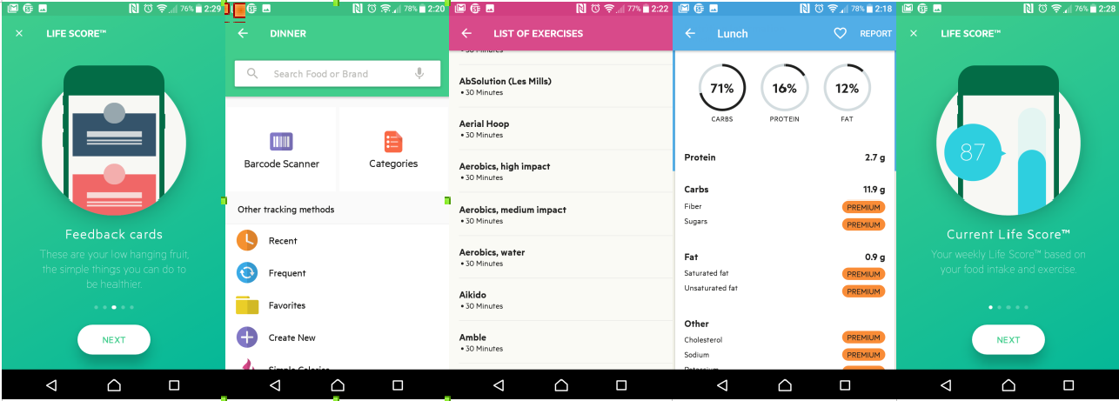

Figure 1 (12,Lifesum.com (2017))

Life Sum keeps track of everything a user eats throughout the day. It does this by separating the breakfast, lunch, dinner, and snacks. It keeps track by showing how many calories a user has left for that day. It even breaks down how much carbs, protein, and fat the user should be eating each day.

Each category (breakfast, lunch...) has a multitude of tracking options :

1. Search bar
2. Categories
   1. Beef
   2. Drinks
   3. Lamb
   4. Food cupboard

Above is a small sample of the range the application offers.

1. History allows the user to see watch over time what they would eat frequently or recently.
2. Favorites this option allows user to enter favorite meals, recipes, and foods

Lifesum also allows the user to monitor how much water they are drinking and how much they should be drinking.

The application uses an incorporated barcode scanner which allows users to scan the barcode of snacks and other food as they are shopping.

There is also a social side to the application which gives tips and inspirational content that users of the application can comment and put up their own thoughts.

The application also has a questionnaire that sums up your life score (based on weight, height and eating habits). The score is then displayed in a result chart

##### Good

* Kcal shows how many calories left for a day
* Water monitor
* Barcode scanner
* Provides recommendations
* Social aspects
* Application can sync with other fitness applications such as Fitbit and google fit

##### Bad

* The amount of choice for each meal

LifeSum is a well-rounded food diary application. The key points that I will take from it are how it interacts with other applications, the barcode scanner and the calories left for a day.

#### Dining Note

(15,Play.google.com. (2017))

50 million downloads

4.6 (1397)

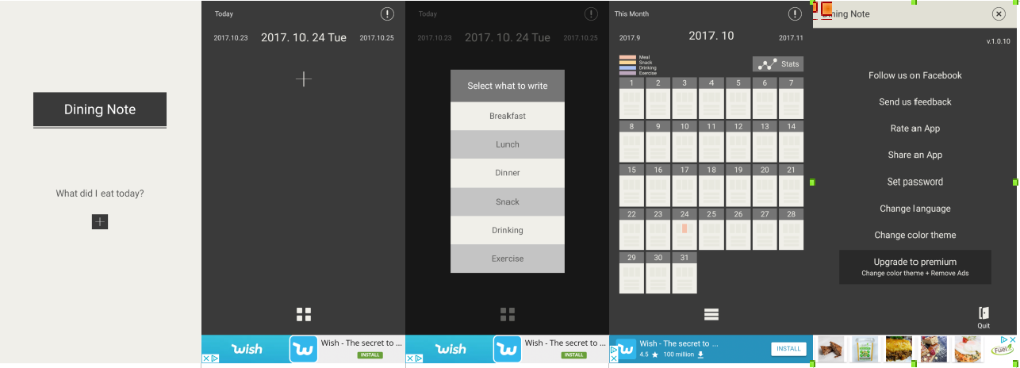

Figure 2 (15,Play.google.com. (2017))

Dining Note starts up with a blank note asking what you eating today. It then allows the user to select which meal they will be entering. Then it prompts the user to enter manually the information on that meal.

Type:

* Breakfast
  1. Enter your meal

Once entered the application will allow the user to view what previous meals they have had in the form of a calendar with different colors for each different food group, and the stats for all of the meals.

##### Good

* Simple interface to use
* Straight to the point only a food diary
* The use of the calendar to show meals

##### Bad

* Not free version ads constantly appear
* Stats could be better
* Entering the data for each meal is time-consuming

The application provides a simplistic way to keeping track of meals. The calendar for keeping track of meals was very interesting.

#### Food Diary

(16,Play.google.com. (2017))

I Million Downloads

3.9 (3641)

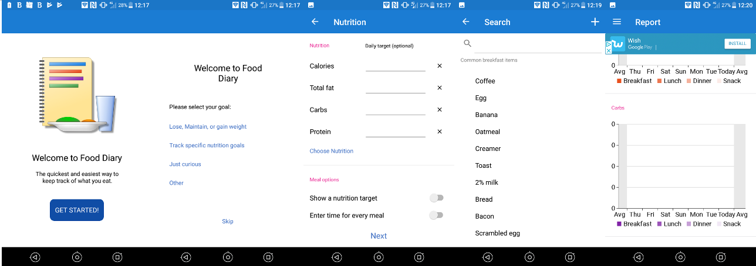

Figure 3 (16,Play.google.com. (2017))

Food Diary like many other applications of its kind prompts the user for what they actually want to achieve from the application under the following headings

* Lose, maintain, or gain weight
* Track-specific nutrition goals
* Just curious
* Other

Once you select one of the following or select other you are then brought a goal page. It allows the user then to input their goals such as

* Date
* Calories
* Total fat
* Carbs
* Protein

Once this information has been inputted it asks the user to enable the application to send reminders for each meal.

The layout of the home page is simple with four main menu heads breakfast, lunch, dinner, and snacks. The top has a menu bar displaying today, journal, reports showing a user's progress using a graphical display, my recipes, and goals.

##### Good

* Asking user what they will be using the application for
* Setting up reminders for each meal
* The way it allows to select foods from a list but also make a note on that food when selecting it.

##### Bad

* It contains ads
* Could use some more functionality such as an advice section or a barcode scanner.

One of the best things I noted about this application was that everything that a food diary should be was all listed on one page all of the meals and the input for the meals was straightforward and allows the user to input their own notes on the specific meal they are having.

Motion tracking applications

(8,Fitbit.com. (2017))

Fitbit

10 million downloads

4.0 (302, 593)

Editors choice

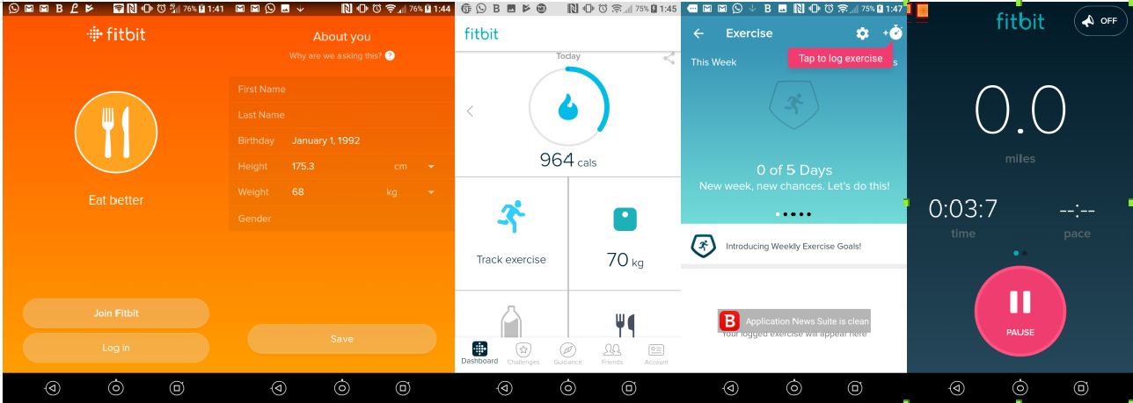

Figure 4 (8, Fitbit.com. (2017))

Fitbit primarily is a fitness tracking application using motion to track the user. It uses a mobile's range of sensors at the basic level but it's there wearable technologies that really gives this application an edge over the other ones allowing more specific sensors built for the application. They include:

* Swim
* Steps
* Sleep
* ...

The Fitbit's sensors can distinguish between walking and light exercise too if you are playing a sport or more demanding exercise.

Fitbits home screen is kept quite simple with steps, miles, and calories and then four squares to track exercise, weight, water intake and what you have eaten today. The footer bar then holds dashboard, challenges, guidance, friends, account.

Good

* The account setup
* The layout of the application
* The sensor features

Bad

* Needs a Fitbit

Overall Fitbit is a well-polished application that works well for tracking fitness but what I will take from this is how external pieces of technologies can improve the application.

### Motion Applications

#### Google Fit

(9, Google.com. (2017))

10 million downloads

3.9 (231,346)

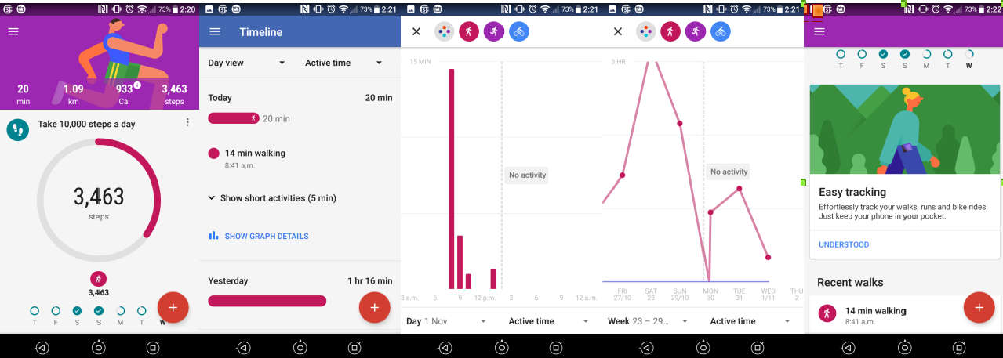

Figure 5 (9,Google.com. (2017))

Google fit is quick to set up. The application can be left running in the background and will track a user's movement. There is a range of different option that can be used with google fit such as :

* How many steps should be taken each day
* Timeline of activity
* Add activity
* Log a user's weight
* Add goal

Google Fit can run completely without any user input apart from when they initially setup the application. The focus on the applications homepage is the step counter everything revolves around it and as a fitness application, it makes it easy to read and use.

##### Good

* Runs autonomously
* Can connect with different applications

Google Fit does everything a basic fitness application needs to do backed up by Google's powerful analytics engine it is a powerful application and the option of using it with other applications already on the market makes it a very adaptable application.

#### Runtastic

(17, Runtastic.com. (2017))

10 million downloads

4.5 (773,024)

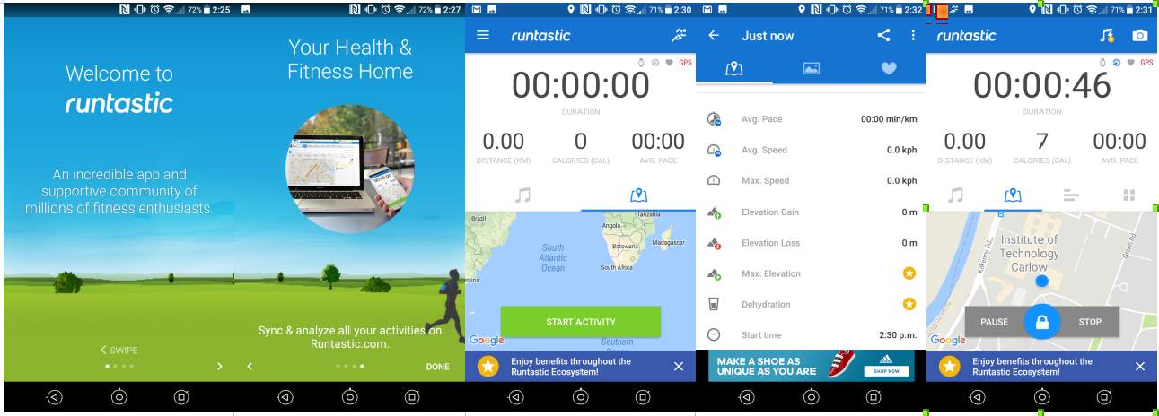

Figure 6 (17, Runtastic.com. (2017))

Runtastic is a running application that uses GPS to track a runner on a specific track. The application is developed with runners in mind. It can monitor the following

* Distance km
* Calories
* Average pace
* Duration
* Speed
* Average Speed
* Dehydration
* Elevation
* Elevation gain
* Elevation loss
* Clock

The application relies heavily on GPS signal and a lot of the above mentioned cannot function without it. Only the most basic parts of the application functions. The application also has a heart rate monitor built in but it relies on wearable smart technology to work.

##### Good

* The range it offers runners

##### Bad

* GPS (In my case there was no GPS available)
* AD’s
* Needs extra bits to use all the applications functionality

Runtastic was an interesting application it got a lot of things right by using GPS but on the other because it relies on this technology and when it is not available the application loses what makes it stand out.

## What is a spirometer

(see Appendix C)

Spirometry is the technique used to measure lung capacity and forced expiratory volume in the 1s amount of air that can be maximally expired in 1s after complete inhalation. This means that this test can show what the patient's lung functionality. The patient takes a deep breath in filling up their lungs (nose is pegged closed) and exhaling fully. By doing this it will show two things the first is the capacity of the patient's lungs by how long they can actually hold the exhale and the second how healthy the lungs are by how far they can push the bell in the apparatus.

Traditionally, this was done with a water-sealed spirometer. The instrument consists of an air-filled bell hanging upside down in a container of water tubing connects the air inside the bell with the patient's mouth, a nose clip occluding nasal airflow with exhalation the bell moves upward with inhalation, it moves downward. Movements of the bell are quantified with a ruler and recorded (Movements are now quantified by a computer that has sensors on the bell and it monitors the movements). Carbon Dioxide is removed from the expiratory gas by an absorber, and oxygen is supplied to the inspiratory gas to compensate for oxygen consumption during the procedure.

### Why use one

Lung disease is the primary cause of death in patients with CF accounting for 90% fatalities in this disorder.

From early infancy onwards, the combination of infection and inflammation causes ongoing damage to the airways leading to progressive loss of lung function.

Slowing down the loss of lung function through reduction of pulmonary infection and inflammation is the cornerstone of treatment in CF.

So, every patient with CF, therefore, it is important to monitor the level of lung function carefully and repeatedly.

## Arduino

(3, Arduino.cc. (2017))

### What is it

Arduino is an open-source platform used for building electronic devices. It consists of both a physical programmable circuit board and a piece of software that runs on a computer used to write and upload code to the physical board.

### What is it used for

The Arduino has become quite popular with people who are starting out with electronics. Unlike other programmable boards such as Raspberry Pi, it does not need a separate piece of hardware (called a programmer) to load to the board, you can simply use a USB cable. The Arduino uses a simplified version of C++, which makes it easier to learn how to program it.

### What and why will I use it for

I will be using the Arduino Uno. Which are one of the more popular boards in the Arduino family and a good choice for a beginner? I will be creating a spirometer mentioned above using the Uno and specific Pressure Sensor (Honeywell RR Transducer ASDXRRX010ND7A5) to measure airflow. I am creating a spirometer to monitor the lung function of patients with CF.

## Sensors

A sensor is a device that detects events or changes in its environment and sends the information to other electronics.

### Arduino sensors

(18, Sensing.honeywell.com. (2017))

#### Honeywell ASDX Series Silicon Pressure Sensor

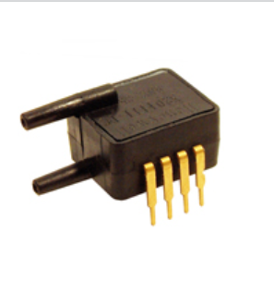

Figure 7 (18, Sensing.honeywell.com. (2017))

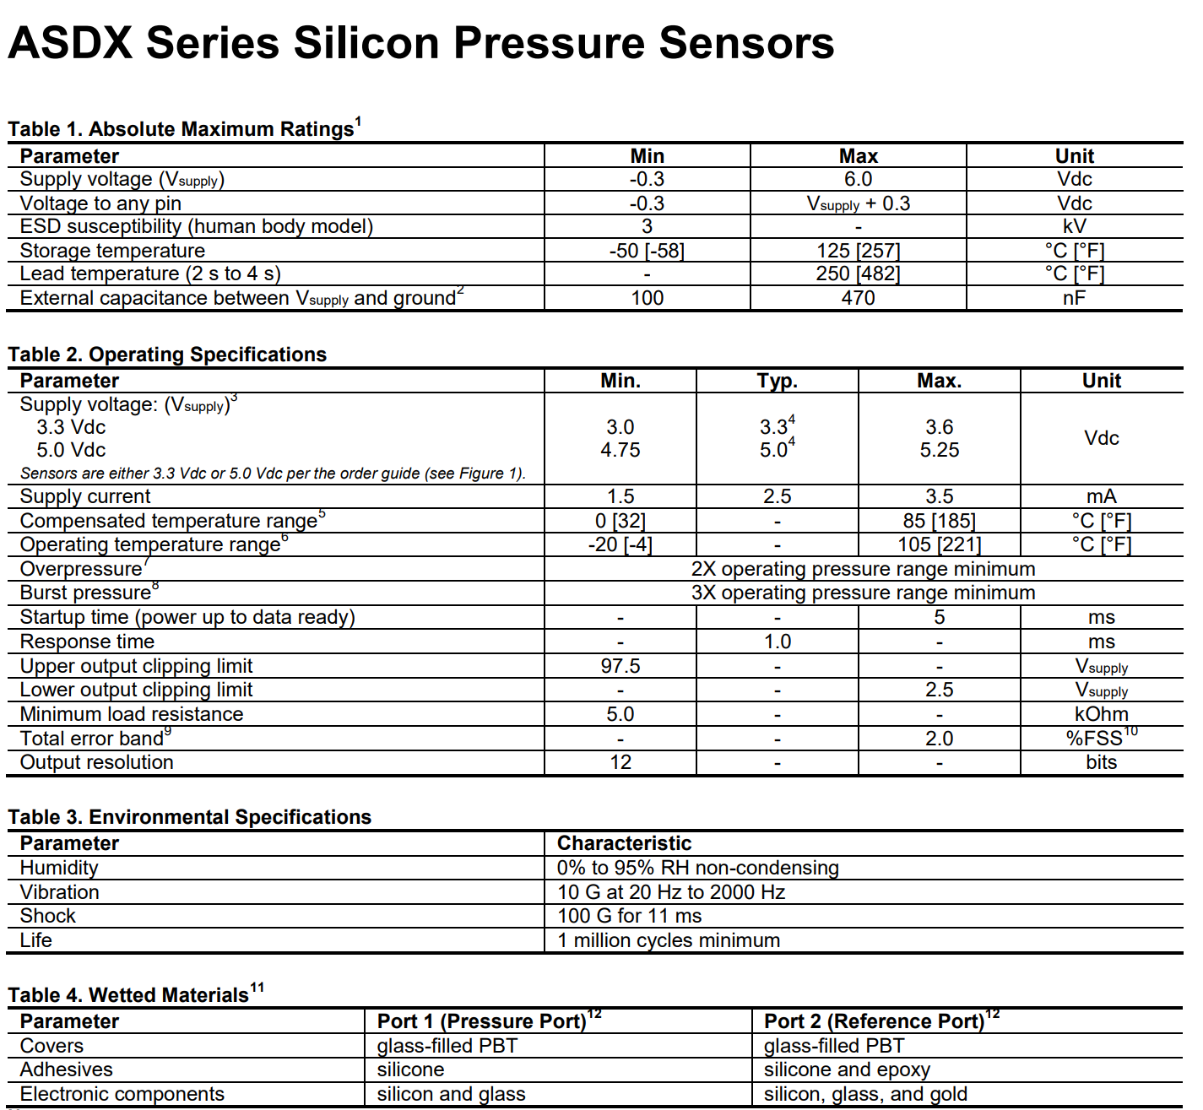

Figure 8 (18, Sensing.honeywell.com. (2017))

The ASDX silicon pressure sensor offers a ratiometric analog interface for reading pressure over specified full-scale pressure span.

#### Heartbeat Monitor

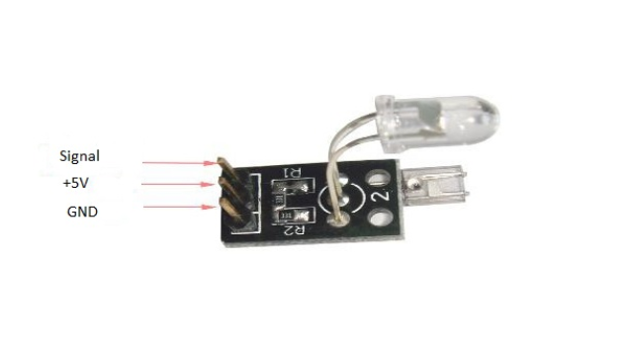

Figure 9 (14, Microcontrollers Lab. (2017))

The heartbeat sensor uses infrared red (IR) and a phototransistor to detect the pulse of a finger and whenever a pulse is detected the red led flashes.

#### Oxygen Sensor

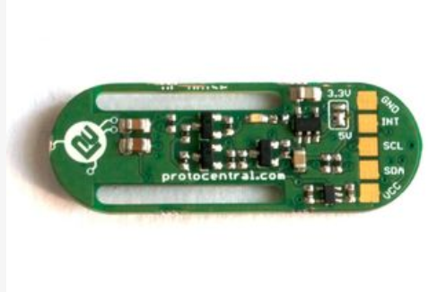

Figure 9 (10, Instructables.com. (2017))

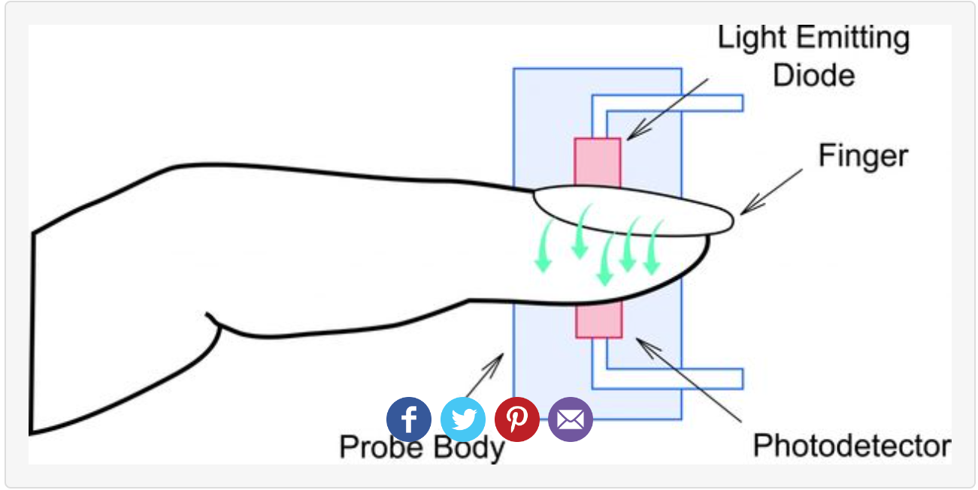

Figure 9 (10, Instructables.com. (2017))

Pulse oximetry operates on the red and IR light absorption characteristics of oxygenated and deoxygenated hemoglobin. Concentration can be calculated from the ratio between the absorption of red light and IR light by the hemoglobin.

### Mobile Sensors

(30, Storm.cis.fordham.edu. (2017).)

#### Types of Sensors

* Proximity and Motion
* Tri-Axial Accelerometer
* Gyroscope
* Temperature and Humidity
* Heart rate (not common)

#### Location

##### Cell tower triangulation

* + Less power compared to GPS - not as accurate
  + Can improve speed of GPS loss and wi-fi can improve the accuracy of GPS

##### Proximity and Motion

* + Measured in centimeters

##### Tri-Axial Accelerometer

* + Common in most smart smartphones and watches
  + Gravity included
  + On Android and IOS default range is +2g to -2g
    - Bigger range means lower resolution
    - Axes are fixed to phone and hence changes as phones shifts
  + Sample rates 20-50hz

##### Gyroscope

* + Determine position and orientation of device
  + Measures rotation in radians seconds about axis
  + Sensitivity to rotation is more robust to motion

##### Temperature and Humidity

* + Track whether and building condition

## Creating a Spirometer

(11, Instructables.com. (2017))

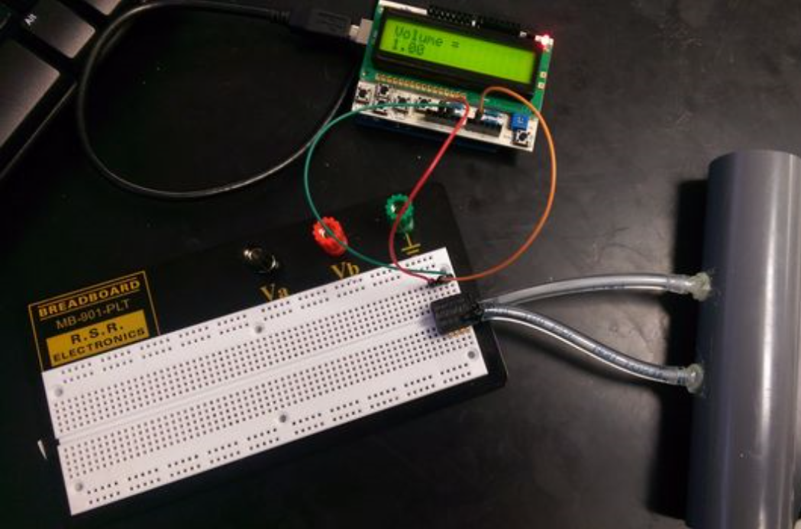

Figure 10 (11, Instructables.com. (2017))

As I am not an electrical engineer I had to find a tutorial to help me figure out the steps that would need to create a spirometer. I followed the following Instructables tutorial.

### Materials

* Pvc pipe (might look for a better solution)
* Plastic tubing
* Glue
* Pressure sensor
* Arduino Uno
* Arduino Uno LCD screen
* Computer
* Micro USB cable
* Bread Board (might not need this)

### Step 1 construct spirometer tube

The tube should have two sections, one with a large diameter and one significantly smaller diameter eg D1 = 2.3, D2 = 0.6 (make larger diameter difference)

### Step 2 select pressure sensor

The only circuit component used for this project is a pressure sensor, Honeywell ASDX series silicon pressure sensor.

Differential pressure sensors are able to convert the difference between two pressure to voltage. A diaphragm is placed between two compartments of the sensor each compartment has a port where pressure can be applied. The diaphragm is attached to a series piezoresistive strain gauges the that are connected in a Wheatstone bridge configuration. As the resistance changes the output of the bridge circuit changes and can be used to calculate the pressure difference. The sensor requires connections to a supply voltage (5V) and ground.

### Step 3 Attach Arduino Uno microcontroller

Another major component of this device is the Arduino Uno microcontroller and a compatible LCD screen with buttons.

Connecting the Arduino to the pressure sensor is very simple you just need to match the sensors pins to the pins on the board. Since the Arduino is able to supply 5V and ground you will be able to power the pressure sensor with the Arduino alone.

Before attaching the wires for the pressure sensor to the Arduino attach the LCD screen to the microcontroller. It should fit into the pins on the Arduino.

### Step 4 Configuration

* Pressure sensor -> Arduino
* Pin 1 -> 5V
* Pin 2 -> A1
* Pin 3 -> GND

Step 4 creating the code :

The following are the steps the tutorial used to explain the logic behind the code :

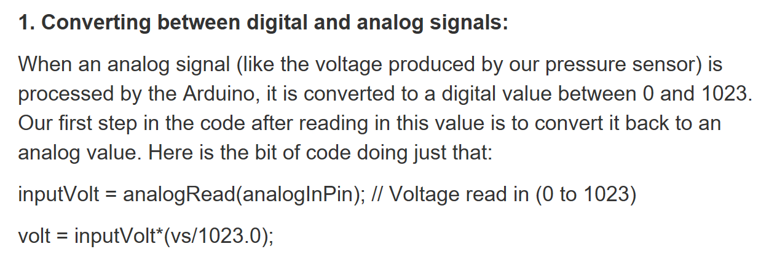

Figure 11 (11, Instructables.com. (2017))

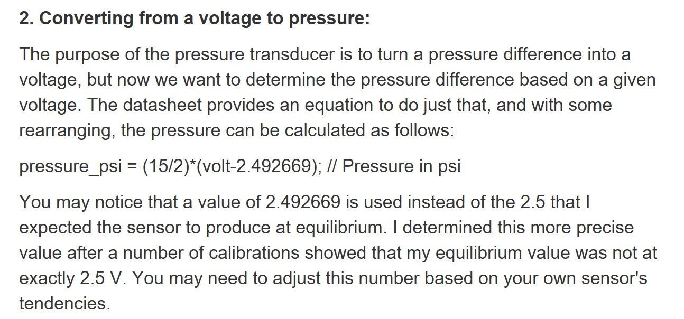

Figure 12 (11, Instructables.com. (2017))

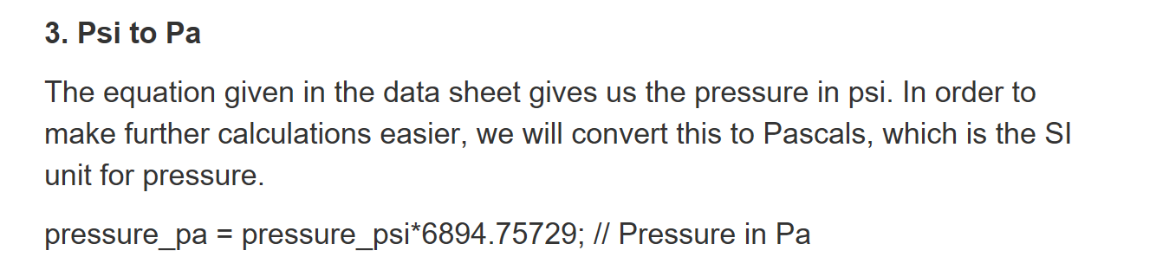

Figure 13 (11, Instructables.com. (2017))

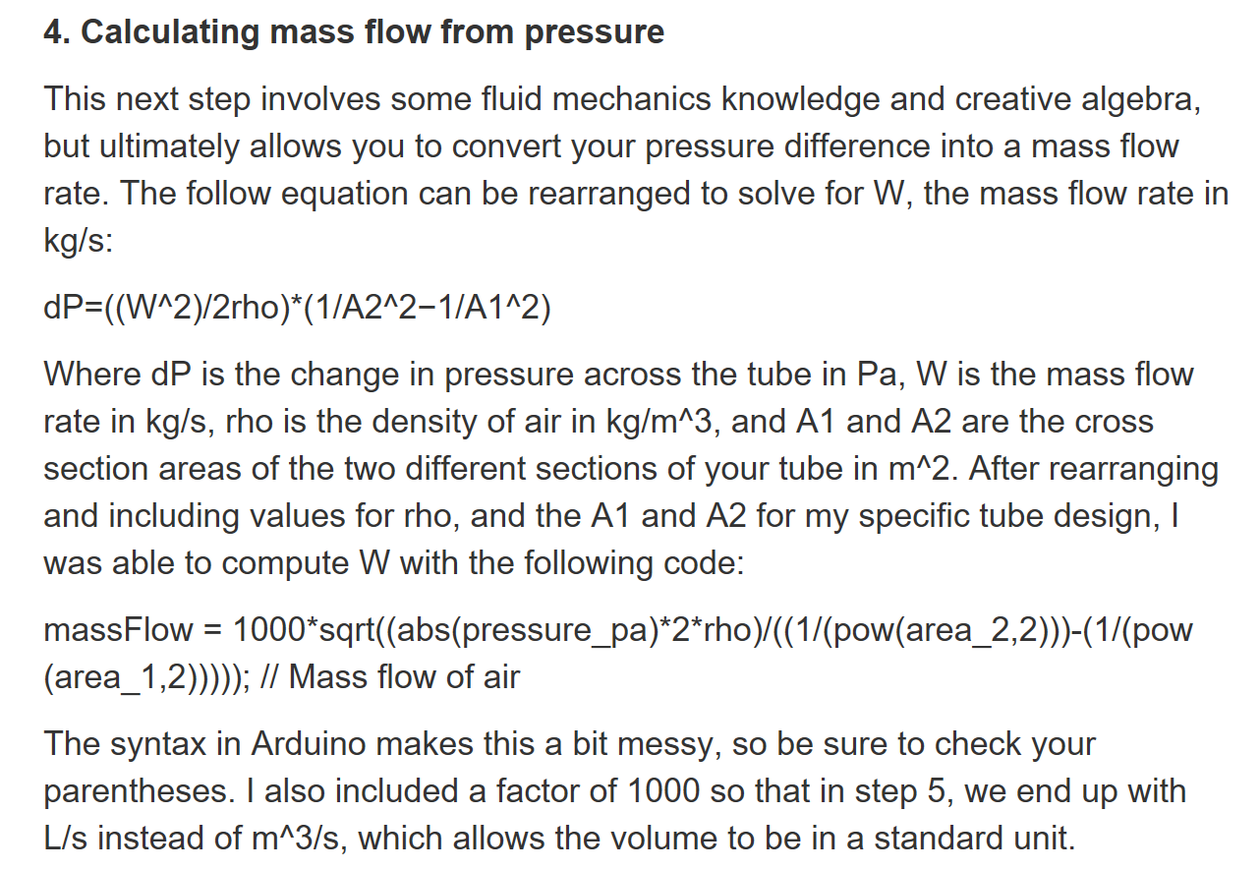

Figure 14 (11, Instructables.com. (2017))

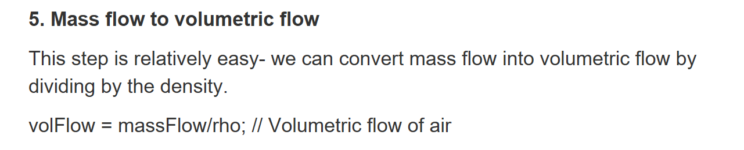

Figure 15 (11, Instructables.com. (2017))

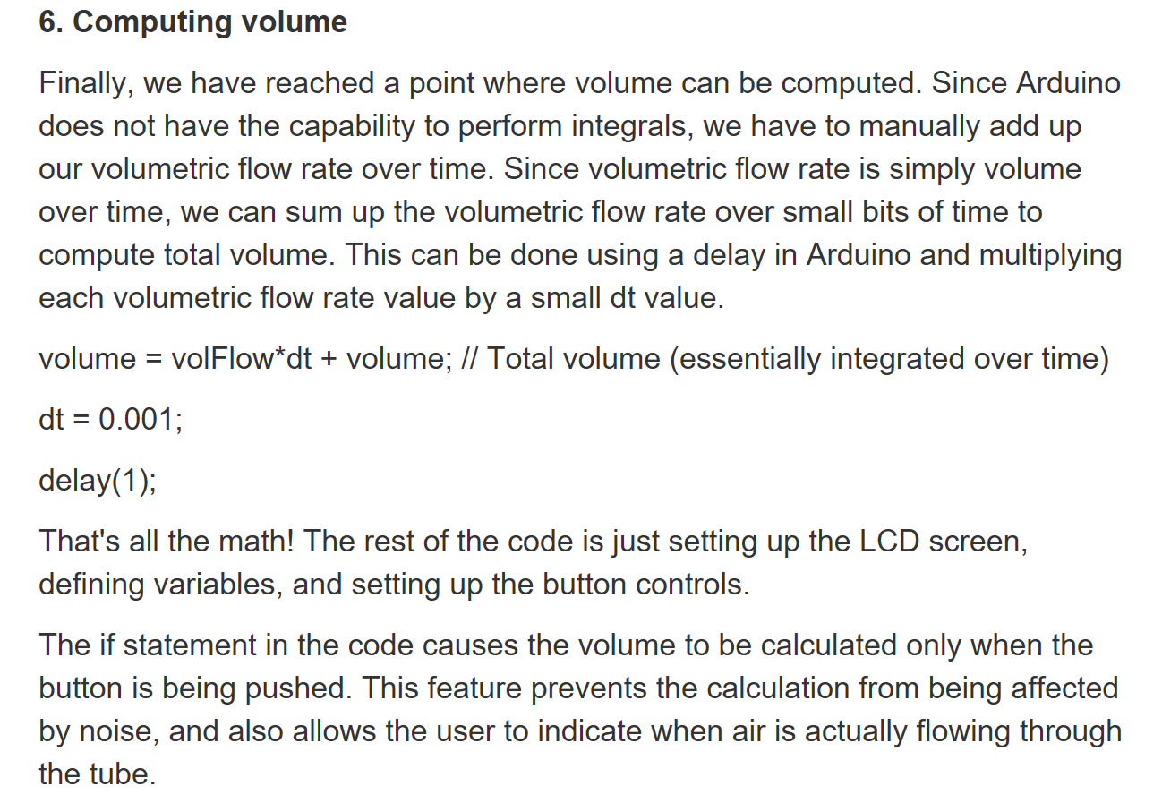

Figure 16 (11, Instructables.com. (2017))

### Step 5

In order to use the device attach the tube from step 1 to the pressure sensor using the two pieces of tubing.

Bring the tube to your mouth and blow through it, while simultaneously pressing the up button on the LCD screen. When finished expiring release the button.

## Why I didn’t make a spirometer

In the end I didn’t create a spirometer for the following reasons:

* Accuracy
* Materials
* Build quality
* 3D Printer

The reasons above outline the reasons why I didn’t build one. It wouldn’t have been as good overall as one that I could purchase.

### Spirometers

#### MIR SMART ONE

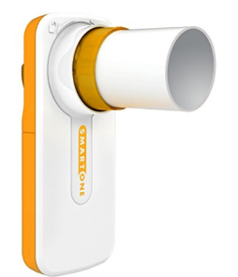

MIR SMART ONE features:

Spirometer for measuring Peak Flow (PEF) and FEV1.

Ready-to-use out of the box.

Easy to use, for everyone from 3 to 95 years.

Connect it to your smartphone via Bluetooth (BLE).

Easy-to-clean (the mouthpiece and turbine are easy to remove for cleaning).

Ideal for monitoring asthma, COPD and your fitness.

Measures your breathing with the maximum accuracy because it is produced by MIR

#### Spirometer Digital Electronic

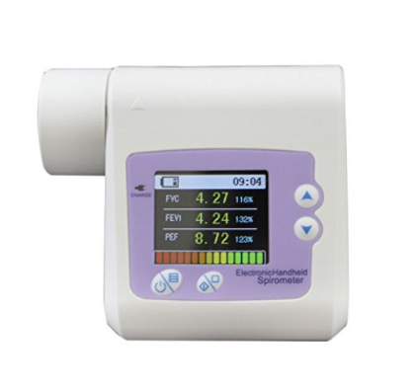

Designed for clinics and home heathcare

User friendly, light weight and portable

1.8" 160x128 TFT display with LED backlight function

Provides rate-volume and volume-time waveform ideal for diagnosis

Inner flash memory for data storage. Easily uploadable to PC via USB

#### Microlife PF-100

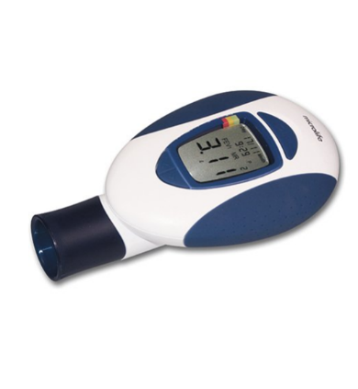

Brand Name Microlife

Ean 0642632732005 , 4719003620028

Global Trade Identification Number 08917350391554

Item Weight 431.0 grams

Model Number PF 100

Number of Items 1

Part Number FBA_PF-100

UPC 642632732005

## Platforms

### Android

(6, En.wikipedia.org. (2017))

Android is one of the most used mobile operating systems. It has close to 88% of the market of all smartphones.

#### Previous versions

* KitKat 4.4 - 4.4.4
* Lollipop 5.0 - 5.1.1
* Marshmallow 6.0 - 6.0.1
* Nougat 7.0 - 7.1.2

#### The newest version of Android is Oreo 8.0



Figure 17 (6, En.wikipedia.org. (2017))

Android also has one the largest range of application on the on the market with over 2 million applications to choose from.

### IOS

(7, En.wikipedia.org. (2017))

Apple uses IOS to power their mobile technology which includes iPhone, IPad and iPod touch.

At the moment Apple is using Ios 11 which was released last September. Apple is the second most popular after Android. (2 Apple (Ireland). (2017))

Apple has also been praised for incorporating thorough accessibility functions into Ios, enabling users with certain disabilities to have a good user experience.

#### Below are some facts about Apple's new flagship phone

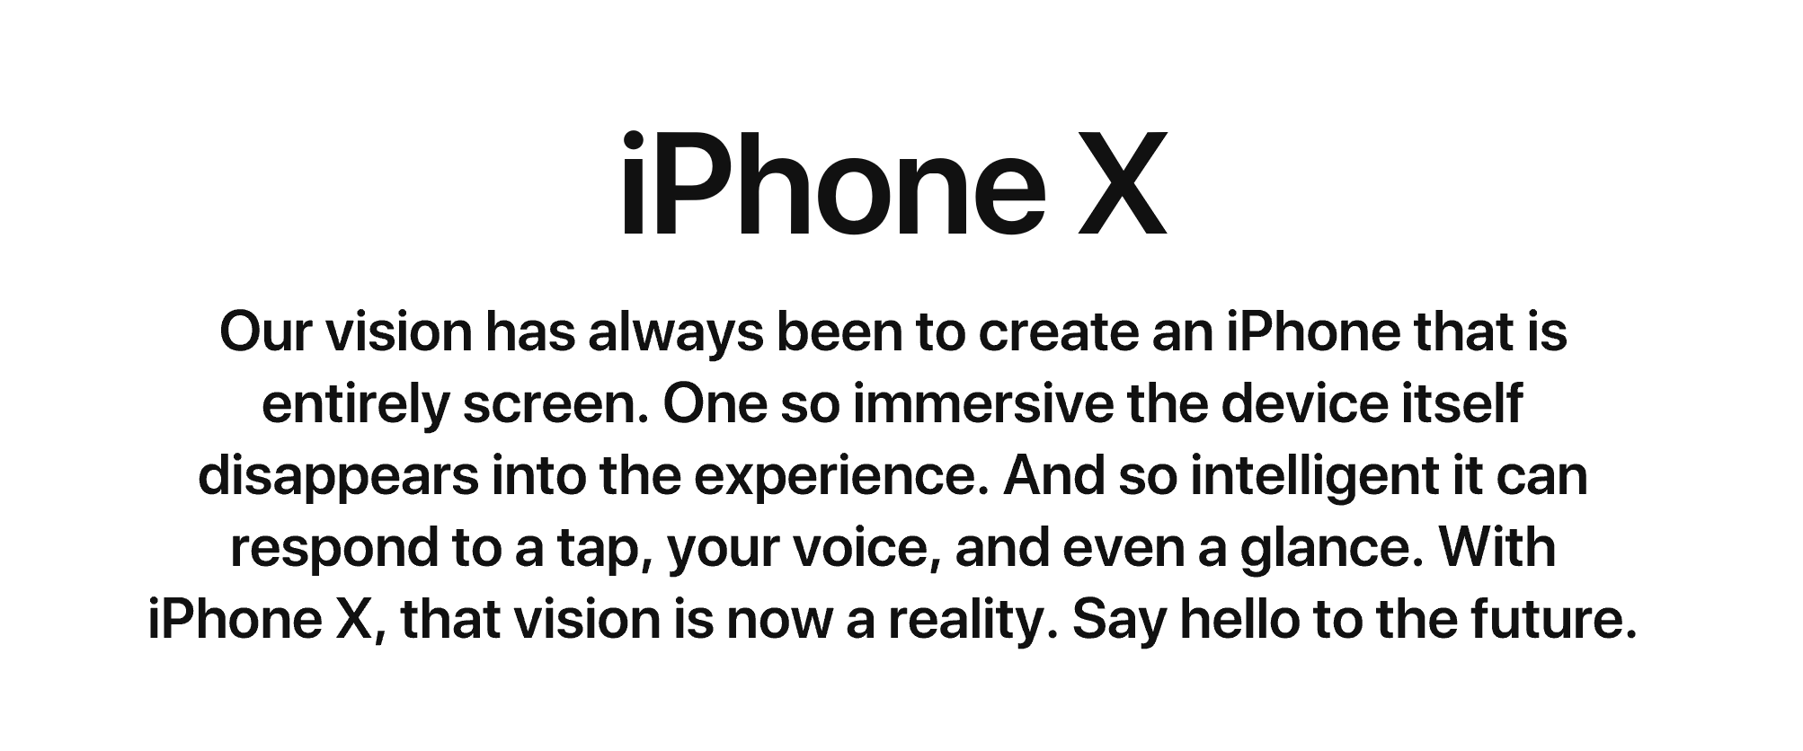

Figure 18 (2 Apple (Ireland). (2017))



Figure 19 (2 Apple (Ireland). (2017))

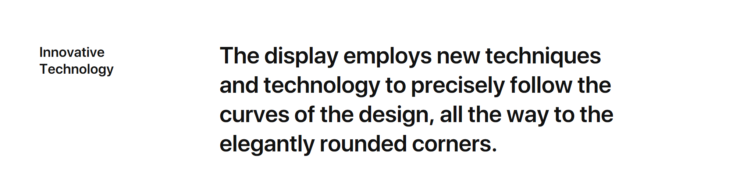

Figure 20 (2 Apple (Ireland). (2017))

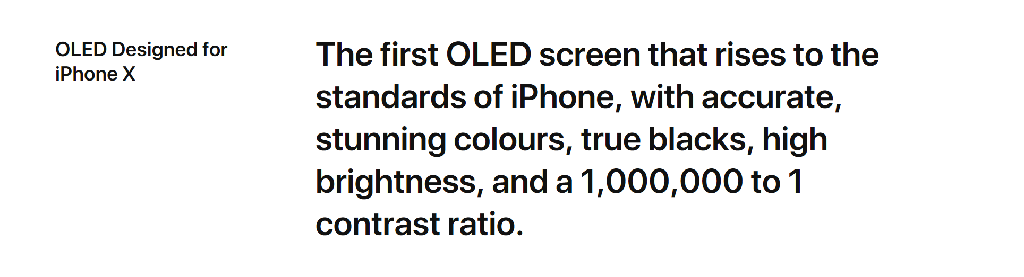

Figure 21 (2 Apple (Ireland). (2017))

### Web Applications

(13, Maxcdn.com. (2017))

I am going to break down what I believe are the main points of a web application.

#### Reliable

The web application needs to load instantly and automatically detect what type of hardware is being used by the user.

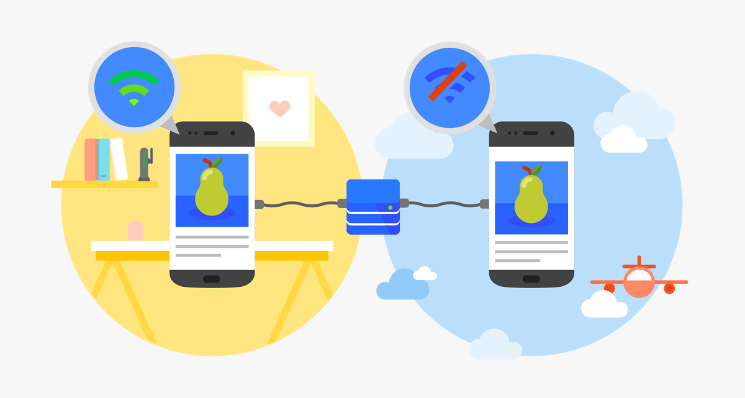

Figure 22 (13, Maxcdn.com. (2017))

#### Fast

“53% of all users will abandon a site or application if it takes longer than 3 seconds”. Users expect everything to load and appear smoothly. If a user has a bad experience with an application more than likely they will never use it again.

Figure 22 (13, Maxcdn.com. (2017))

#### Engaging

A web application can be installed on the user's homepage without the use of an app store. The application must provide an immersive full-screen experience.



Figure 23 (13, Maxcdn.com. (2017))

## Native v Web Application

### Native applications

(28, Nielsen Norman Group. (2017))

Native applications live on the device and are all accessed through icons on the device's home screen. These applications have to be installed from an application store (IOS. Android). They are developed for one type of mobile operating system and can take advantage of all of the features of that device such as GPS, camera and they can also incorporate gestures(either standard or application defined). Native applications can also utilize the devices notification system.

#### Good

* Access to all of the devices features
* Ability to work offline
* Ability to integrate with device notification system

#### Bad

* Limitations can only be used with one mobile OS
* Costly as if you are developing the application for multiple devices then each new device will need its own unique version of the application

### Web Applications

(27, Maxcdn.com. (2017))

Web applications are not real applications, they really are smart websites that in many ways feel like native applications but are not implemented as such.

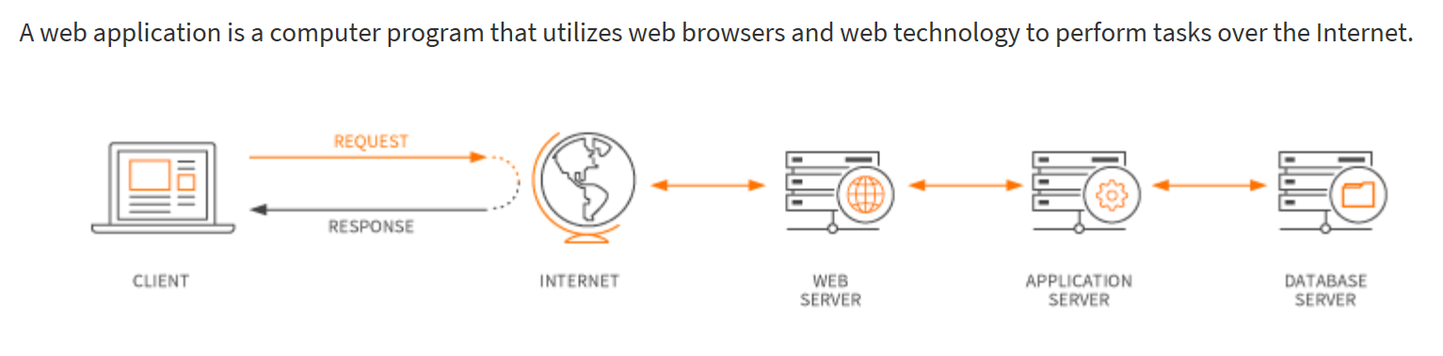

Figure 24 (27, Maxcdn.com. (2017))

Web applications use a combination of server-side scripts (PHP, ASP) to handle the storage and retrieval of the information and client-side scripts (Javascript and HTML) to present information to the users.

Web applications are usually coded in a browser - supported language such as Javascript and HTML as these languages rely on the browser to render the program executable. Some applications are dynamic, requiring server-side processing. Others are completely static with no processing required at the server.

#### Good

* Will work all almost all devices
* Ability to access mobile hardware
* Cheaper to develop

#### Bad

* Need to connect to the internet

## Development Tools

(22, Developer.android.com. (2017)

### Android studio

Android studio provides the fastest tools for building applications on every type of Android device. It contains code editing, debugging, performance tooling and flexible build system.

#### Features

Code and iterate faster than ever :

* Instance run
* Intelligent code editor
* Fast and feature rich emulator

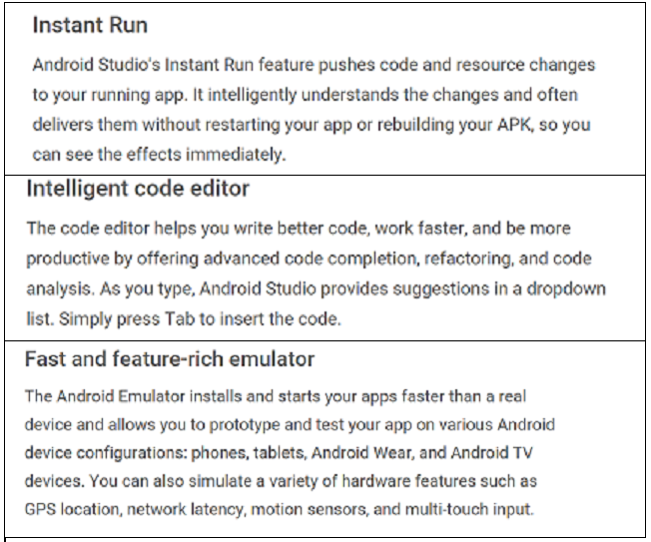

Figure 25 (22, Developer.android.com. (2017)

#### Config builds without limits

* Designed for teams
* Optimized for all android devices
* Robust and flexible build system

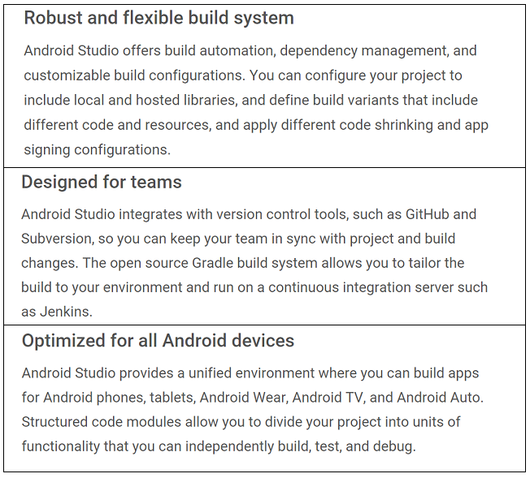

Figure 26 (22, Developer.android.com. (2017)

#### Code with confidence

* Linteligence
* Testing tools and frameworks
* Code templates and sample applications

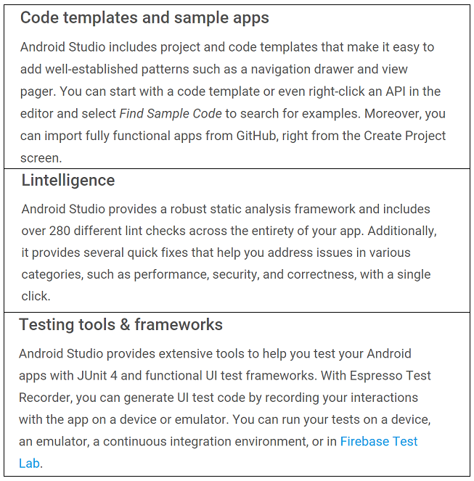

Figure 27 (22, Developer.android.com. (2017)

#### Create rich and connected applications

* C++ and NDK support
* Firebase and cloud integration

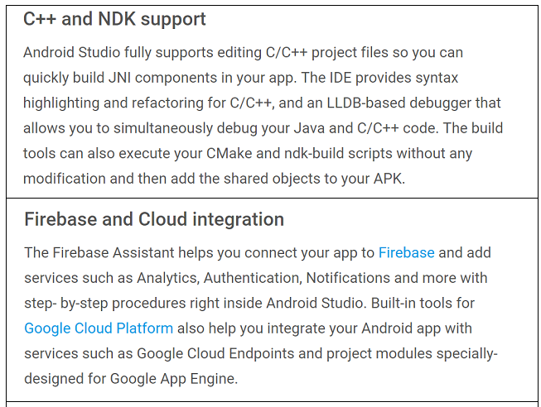

Figure 28 (22, Developer.android.com. (2017)

#### Eliminate tiresome tasks

* Layout editor
* APK analyser
* Vector asset studio

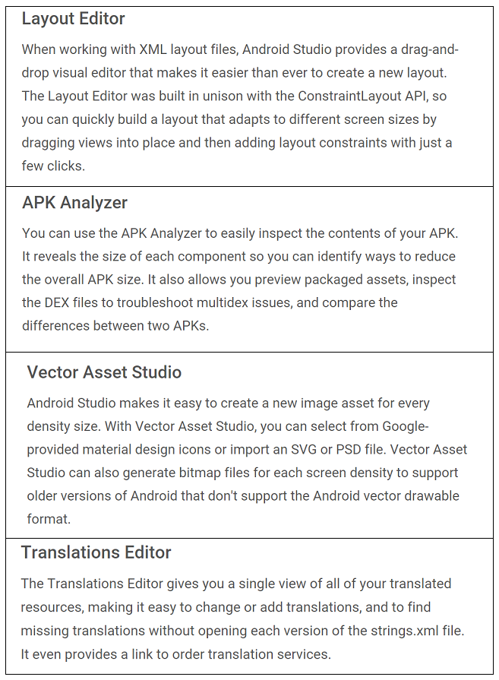

Figure 29 (22, Developer.android.com. (2017)

I also spent some time using android studio myself. I followed two tutorials

#### Tutorial 1

The first was a simple android counter that a user would click and it would keep count of how many times it was clicked.

The tutorial can be found here: <https://www.youtube.com/watch?v=gyHpBrBZle8>

The finished Application can be found here: <https://github.com/LorcanHbermingham88/androidCounterApp>

#### Tutorial 2

The second tutorial was an android step counter. The counter used the phone's sensors to measure a number of steps that were taken.

The tutorial can be found here: <https://www.youtube.com/watch?v=CNGMWnmldaU>

The finished application can be found here: <https://github.com/LorcanHbermingham88/step_monitor>

### Ionic 2

(26, Ionic.io. (2017))

Ionic was started in 2013, the aim was to make a better way for web developers to use their existing skill set to build applications for application stores.

Over the last two years, millions of developers from nearly every industry around the world have built over 1.2 million mobile applications with ionic.

#### Ionic CLI

* The clip is a tool that provides a number of helpful commands to the developer

#### Components

* Components are reusable UI elements
* They are made up of HTML, CSS, JavaScript
* They adapt to the platform on which the application is running

#### Theming

* Styles that get applied to an application

#### Angular

(20, Angular.io. (2017))

* This is the framework ionic 2 uses for building client applications in HTML and JavaScript or a language like A TypeScript
* Angular applications are composed of by HTML templates with Angularized markup, writing component classes to manage those templates adding application logic

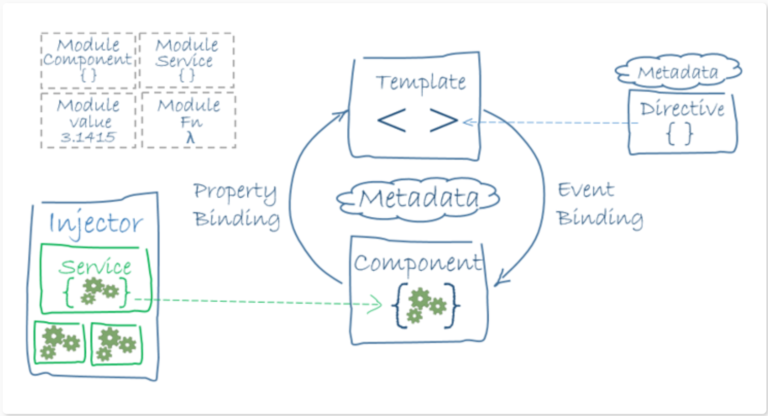

Figure 30 (20, Angular.io. (2017))

## Technologies

### Backend

(24, Home, H., Development, W. and Development, A. (2017)

The traditional backend is a mix of the server, database, API and operating systems that power the applications front end.

The backend of an application can look very different from application to application whether it's the use of a cloud-based-server and data warehouses, containerization with a service like a docker, backend-as-a-service(BaaS), or APIs to replace more complex processing.

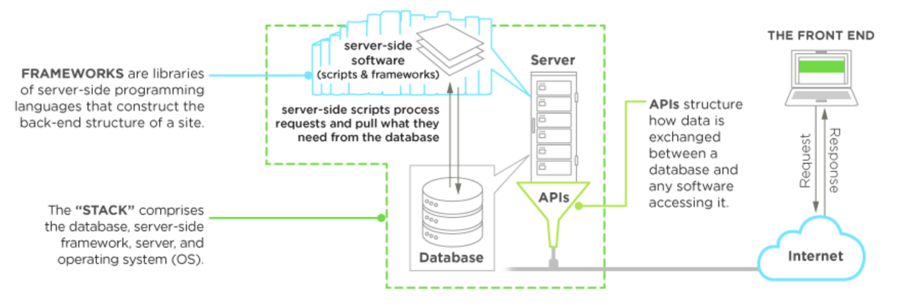

Figure 31 Home, H., Development, W. and Development, A. (2017

#### PHP

When it comes to backend technologies PHP is one of the most common and most popular languages. It has a syntax very similar to C or Java.

#### Python

Python is a language that users find simpler than PHP. It is designed to have a very readable code.

Its well tested and Google choose to develop their services with it.

One of the most popular frameworks for python is Django.

#### Ruby

Ruby is designed to be a fun language. It has a focus on simplicity and productivity with a syntax.

In ruby, everything is an object and that's interesting because it encourages the programmer to think this way when developing.

The most popular framework for ruby on rails.

### Databases

I will be covering two different types of databases Relational and Non-Relational databases.

Relational databases use SQL which stands for Structured Query Language. SQL is used to communicate with a database. It is the standard for relational database management systems. SQL statements are used to perform tasks such as update data or retrieve data from a database.

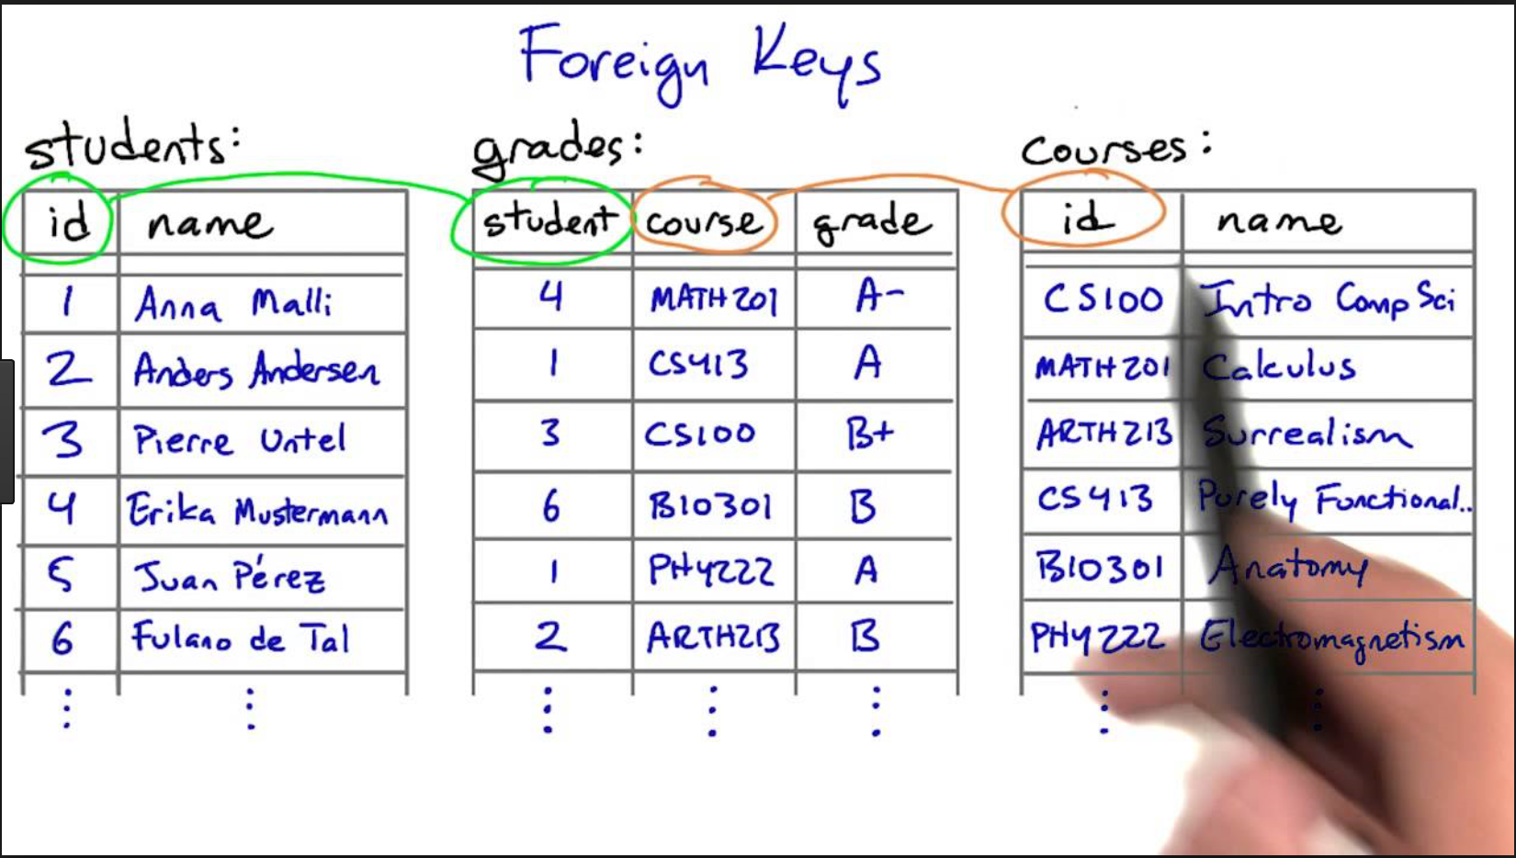

Figure 32

Non-Relational databases encompass a wide variety of different database technologies that were developed in response to the demands presented in building modern applications.

* Developers are working with an application that creates massive volumes of new rapidly changing data types structured, semi-structured, unstructured and polymorphic data.
* Applications that once served a finite audience are now delivered as services that must be always-on accessible from many different devices and scaled globally to millions of users.

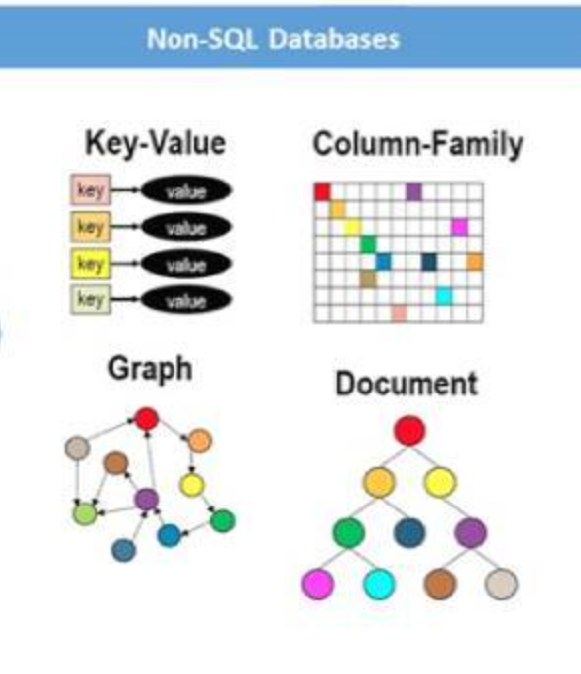

Figure 33

#### Firebase

(23, Firebase. (2017))

Firebase is a NoSQL cloud database data is synced across all clients in real time and remains available when a device goes offline.

Data is stored as JSON and synced in real-time to every connected client if you build cross-platform applications with IOS, Android, and Javascript SDKs all of your clients share one real-time database instance and will automatically retrieve updates with the newest data.

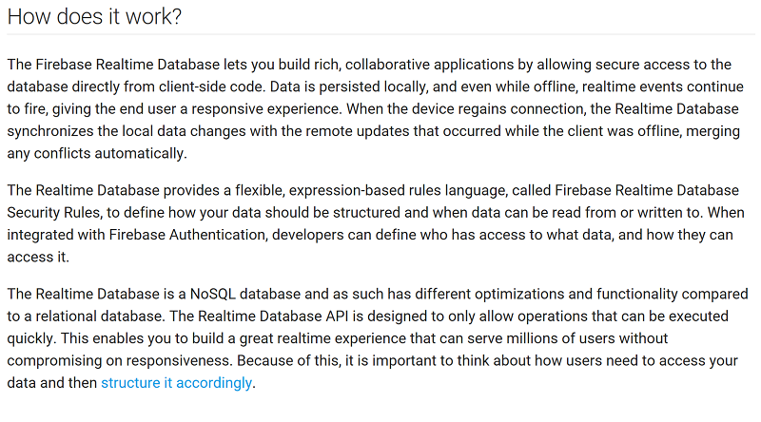

Figure 34 (23, Firebase. (2017))

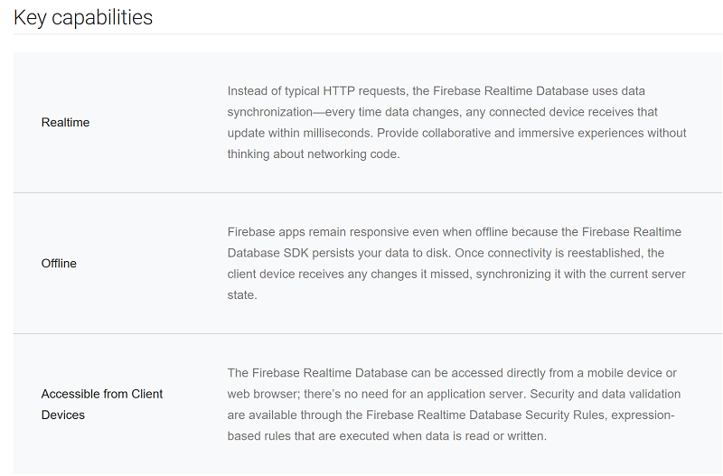

Figure 35 (23, Firebase. (2017))

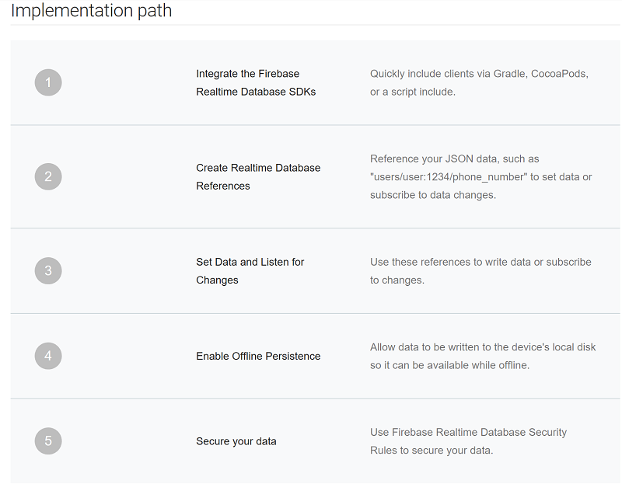

Figure 36(23, Firebase. (2017))

##### Good

* Can adapt to incoming data
* Grows with your application
* Powered by google AUTH

##### Bad

* Relatively new
* Structuring data at beginning can be time-consuming

#### SQLite

(29, Sqlite.org. (2017))

SQLite is an in-process library that implements a self-contained serverless, zero-configuration, transactional SQL database engine.

SQLite is an embedded SQL database engine, unlike most other SQL databases SQLite does not have a separate server process. SQLite read and writes directly to ordinary disk files this means that a complete SQL database with multiple tables, indices, triggers, and views is contained in a single disk file.

SQLite has been very carefully tested prior to every release and has a reputation for being very reliable. Most SQLite source code is devoted purely to testing and verification an automated test suite runs millions and millions of test cases involving hundreds of millions of individual SQL statements and achieves 100% branch test coverage.

##### Good

* A complete database is stored in one file.
* Intensive testing
* Good documentation

##### Bad

* Database stored user device
* Fixed size

## Security

(25, iMedicalApps. (2017))

### Mobile

Mobile web applications download their data in a central database. The good data is not stored on a local device often for security reasons instead it stored at a central location that can be accessed by users of the application.

Because there are stored at a central location security is easier. Protect the server and the transmission (at all costs) and the data will be protected. Users only download one record or one subset of the data. They then upload a modified or new instance of the data. A security breach on a device would only compromise a limited subset of the data.

### Cloud

Cloud devices are basically servers with a fancy name, often offered as a service type, you can sign-up for space on a shared server (cheaper) or a dedicated server (more expensive)

All medical applications that use protected health information should use a HIPAA compliant cloud service. This basically means that the service uses HTTPS (using SSL) for its transmission security as well as secure authentication logins good physical security, encrypted hard drives and so on.

## Conclusion

While I have been doing my research, I have narrowed down the more important aspects of the application. The medical feedback has led me to focus on two areas of the application.

I decided to go with the Microlife PF 100 Peak Flow Meter for Spirometry with FEV1 spirometer as it was easily available for postage and hit all of the requirements that I needed

The second area is the food diary keeping track of more than just the food that intake. It could be expanded to take in diabetes information, medication information and so on.

I have decided to use a No-SQL Firebase database as it will enable my application to grow as needed not to be fixed to a certain size or by what type of data is going into the database.

To develop the application, I am going to use android studio as the tutorials I have followed have been straightforward and there is good documentation backing it up but then I would be limiting my application to the android market which I am mindful of. Also android studio integrates easily into firebase.

# Appendices

(A)(32, Goddard, A., Staudinger, B., Dowd, S., Joshi-Datar, A., Wolcott, R., Aitken, M. and Singh, P. (2012).) Most patients with cystic ﬁbrosis (CF) die from progressive lung damage caused by chronic airway infections (1). For many years, clinicians have focused on a relatively limited number of bacterial species in CF, including Haemophilus inﬂuenzae, Pseudomonas aeruginosa, Staphylococcus aureus, Burkholderia cepacia complex, and a few others (2). These organisms have been considered “typical” CF pathogens and have been linked to disease pathogenesis by airway culture results, clinical experience, and epidemiological data (1, 3). However, recent work using culture-independent identiﬁcation methods suggests that CF airways may be infected by many more bacterial species than appreciated previously (4–11). For example, analysis of bronchoalveolar lavage (BAL) samples found that ∼25% of children harbor organisms not typically associated with CF (9).Studiesusingnewermethodsareevenmorestriking.Hundreds tothousandsofbacterialtaxaperpatienthavebeenfoundinthroat and sputum samples analyzed with DNA-based methods (5–7). This work has raised the possibility that previously unrecognized species may be present in the lower airways and contribute to the devastating clinical manifestations of CF. Indeed, these ﬁndings have begun to in ﬂuence clinical practice recommendations and fundamentally alter understanding of the disease (12–14). An important outstanding question, however, is whether DNAbasedanalysesofupper-airwayspecimensaccuratelyrepresentthe composition of lung microbiota. This issue is critical because sputum, throat, and BAL samples are prone to contamination because bacteria from the mouth, sinuses, or pharynx could mix with expectorated samples or contaminate bronchoscopes and

collection swabs(15,16).Inaddition, DNA-basedmeasurements may be more sensitive than culture (17, 18) and, unlike cultures performed by clinical laboratories, results are not ﬁltered to disregard organisms that could be contaminants (19, 20). Finally, DNA-based methods are primarily used to identify organisms not typically considered pathogens in CF (12, 21). Many of these species are normal inhabitants of upper airways (22). The goals of this study were to answer three key questions. First, how do DNA-based measurements on upper-airway specimens compare with directly obtained lung samples? Addressing this question is vital to interpreting culture-independent measurements on upper-airway samples obtained at any stage of the disease. Second, what bacterial taxa are present in the lower airways of CF patients with established chronic infections? Identifying the resident bacteria is critical to understanding disease mechanisms. Third, are different bacterial species consistently found in different anatomic regions of the lung? Finding such differences might explain the regional variation in lungdisease severity characteristic of CF (23). To answer these questions, we devised a sterile dissection technique to isolate secretions from the lobar airways of CF lungs removed at the time of lung transplantation. We then measured the composition of the airway microbiota using 16S rRNA gene amplicon pyrosequencing and compared results to paired throat and sputum samples collected hours earlier. Results Lung Explant Sampling. We devised sampling methods to meet several objectives. We sought to collect endobronchial secretions rather than tissue sections, because CF lung disease is thought to be caused by intraluminal bacteria (24). We focused on lobar bronchi, because these are likely to be less prone to contamination via aspiration than the main airways, and because they should contain distal secretions brought forward by mucociliary clearance. In addition, we sought to minimize cross-contamination between lung segments, so that regional differences in microbiota could be identiﬁed. To accomplish these goals, we dissected lung parenchyma away from the exterior aspect of the

Author contributions: A.F.G., B.J.S., M.L.A., C.L.F., and P.K.S. designed research; A.F.G., B.J.S., S.E.D., A.J.-D., and C.L.F. performed research; A.F.G., S.E.D., R.D.W., M.L.A., and P.K.S. analyzed data; S.E.D., R.D.W., and C.L.F. contributed new reagents/analytic tools; and A.F.G. and P.K.S. wrote the paper. The authors declare no conﬂict of interest. *This Direct Submission article had a prearranged editor. Freely available online through the PNAS open access option. Data deposition: The sequence data reported in this paper have been deposited in the National Center for Biotechnology Information Sequence Read Archive, http://www.ncbi. nlm.nih.gov/Traces/sra/ (accession no. SRX084386). 1Present address: Department of Pediatrics, Floating Hospital for Children, Tufts Medical Center, Boston, MA 02111. 2To whom correspondence should be addressed. E-mail: singhpr@u.washington.edu. This article contains supporting information online at www.pnas.org/lookup/suppl/doi:10. 1073/pnas.1107435109/-/DCSupplemental.

www.pnas.org/cgi/doi/10.1073/pnas.1107435109 PNAS | August 21, 2012 | vol. 109 | no.

(B)(33, Li, L. and Somerset, S. (2014)) Cystic fibrosis can affect food digestion and nutrient absorption. The underlying mutation of the cystic fibrosis trans-membrane regulator gene depletes functional cystic fibrosis trans-membrane regulator on the surface of epithelial cells lining the digestive tract and associated organs, where Cl− secretion and subsequently secretion of water and other ions are impaired. This alters pH and dehydrates secretions that precipitate and obstruct the lumen, causing inflammation and the eventual degradation of the pancreas, liver, gallbladder and intestine. Associated conditions include exocrine pancreatic insufficiency, impaired bicarbonate and bile acid secretion and aberrant mucus formation, commonly leading to maldigestion and malabsorption, particularly of fat and fat-soluble vitamins. Pancreatic enzyme replacement therapy is used to address this insufficiency. The susceptibility of pancreatic lipase to acidic and enzymatic inactivation and decreased bile availability often impedes its efficacy. Brush border digestive enzyme activity and intestinal uptake of certain disaccharides and amino acids await clarification. Other complications that may contribute to maldigestion/malabsorption include small intestine bacterial overgrowth, enteric circular muscle dysfunction, abnormal intestinal mucus, and intestinal inflammation. However, there is some evidence that gastric digestive enzymes, colonic microflora, correction of fatty acid abnormalities using dietary n − 3 polyunsaturated fatty acid supplementation and emerging intestinal biomarkers can complement nutrition management in cystic fibrosis.

(C) (34, Ramsey, K. and Ranganathan, S. (2014))Pulmonary function tests (PFTs) are noninvasive diagnostic tests that evaluate the functionality of the lungs. Spirometry is an established diagnostic tool for the evaluation and management of lung disorders. Pulmonary function testing carried out using a spirometer provides vital information about the functional status of the respiratory system. In this study, a spirometer based on a fiber Bragg grating (FBG) sensor for PFT has been proposed. The proposed fiber Bragg grating spirometer (FBGS) is a novel, noninvasive device that has the ability to convert the rate of air flow into strain variations using an FBG sensor bonded on a cantilever. The FBGS dynamically acquires in real time, the complete breath sequence comprising of inhalation phase, pause phase, and exhalation phase, in terms of the air flow rate along with the time duration of each phase. Fundamental pulmonary parameters such as forced vital capacity (FVC), forced expiratory volume in the first second (FEV1), the FEV1/FVC ratio, and peak expiratory flow are evaluated from the data obtained from the FBGS, which will aid greatly during clinical tests. The results from the FBGS developed are compared with a standard hospital grade pneumotachograph-based spirometer for a sample size of 16 subjects to prove the efficacy of the proposed device.

<https://www.osapublishing.org/jlt/abstract.cfm?uri=jlt-34-24-5682>

Bibliography

### References

1. Accelerometer, G. and SS-SEN21853P, I. (2017). *Grove - 3-Axis Accelerometer*. [online] Trossenrobotics.com. Available at: http://www.trossenrobotics.com/p/grove-3-axis-accelerometer-sensor.aspx [Accessed 5 Nov. 2017].
2. Apple (Ireland). (2017). *iPhone X*. [online] Available at: https://www.apple.com/ie/iphone-x/ [Accessed 6 Nov. 2017].
3. Arduino.cc. (2017). *Arduino - Home*. [online] Available at: https://www.arduino.cc/ [Accessed 5 Nov. 2017].
4. Bhattacharya, A. (2017). *Android just hit a record 88% market share of all smartphones*. [online] Quartz. Available at: https://qz.com/826672/android-goog-just-hit-a-record-88-market-share-of-all-smartphones/ [Accessed 6 Nov. 2017].
5. Circuitdigest.com. (2017). *Arduino Based Heart Rate Monitor Project*. [online] Available at: https://circuitdigest.com/microcontroller-projects/heartbeat-monitor-project-using-arduino [Accessed 5 Nov. 2017].
6. En.wikipedia.org. (2017). *Android version history*. [online] Available at: https://en.wikipedia.org/wiki/Android_version_history [Accessed 6 Nov. 2017].
7. En.wikipedia.org. (2017). *IOS*. [online] Available at: https://en.wikipedia.org/wiki/IOS [Accessed 6 Nov. 2017].
8. Fitbit.com. (2017). *Fitbit Official Site for Activity Trackers & More*. [online] Available at: https://www.fitbit.com/ie/home [Accessed 5 Nov. 2017].
9. Google.com. (2017). *Google Fit*. [online] Available at: https://www.google.com/fit/ [Accessed 5 Nov. 2017].
10. Instructables.com. (2017). *Finger Pulse Oximeter Using MAX30100*. [online] Available at: http://www.instructables.com/id/Finger-Pulse-Oximeter-Using-MAX30100/ [Accessed 5 Nov. 2017].
11. Instructables.com. (2017). *Low Cost Spirometer*. [online] Available at: http://www.instructables.com/id/Low-Cost-Spirometer/ [Accessed 6 Nov. 2017].
12. Lifesum.com. (2017). *Lifesum Health App - Get Healthy, Lose Weight, or Gain Muscle – Lifesum*. [online] Available at: https://lifesum.com/ [Accessed 5 Nov. 2017].
13. Maxcdn.com. (2017). *What is a Web Application?*. [online] Available at: https://www.maxcdn.com/one/visual-glossary/web-application/ [Accessed 6 Nov. 2017].
14. Microcontrollers Lab. (2017). *heart beat sensor with Arduino|heart pulse measurement*. [online] Available at: http://microcontrollerslab.com/heart-beat-sensor-arduino/ [Accessed 5 Nov. 2017].
15. Play.google.com. (2017). *Cite a Website - Cite This For Me*. [online] Available at: https://play.google.com/store/apps/details?id=com.fourthmaysoft.diningnote [Accessed 5 Nov. 2017].
16. Play.google.com. (2017). *Cite a Website - Cite This For Me*. [online] Available at: https://play.google.com/store/apps/details?id=com.dailybits.foodjournal&hl=en [Accessed 5 Nov. 2017].
17. Runtastic.com. (2017). *Runtastic: Running, Cycling & Fitness GPS Tracker*. [online] Available at: https://www.runtastic.com/ [Accessed 5 Nov. 2017].
18. Sensing.honeywell.com. (2017). *Cite a Website - Cite This For Me*. [online] Available at: https://sensing.honeywell.com/honeywell-sensing-asdx-series-analog-pressure-sensors-product-sheet-008090-12-en.pdf [Accessed 5 Nov. 2017].
19. Storm.cis.fordham.edu. (2017). *Presentations*. [online] Available at: http://storm.cis.fordham.edu/~gweiss/presentations.html [Accessed 5 Nov. 2017].
20. Angular.io. (2017). *Angular Docs*. [online] Available at: https://angular.io/docs [Accessed 6 Nov. 2017].
21. Davidmles.com. (2017). *Technologies used for backend development – David Morales*. [online] Available at: https://davidmles.com/backend-technologies/ [Accessed 6 Nov. 2017].
22. Developer.android.com. (2017). *Download Android Studio and SDK Tools | Android Studio*. [online] Available at: https://developer.android.com/studio/index.html [Accessed 6 Nov. 2017].
23. Firebase. (2017). *Firebase Realtime Database  |  Firebase Realtime Database  |  Firebase*. [online] Available at: https://firebase.google.com/docs/database/ [Accessed 6 Nov. 2017].
24. Home, H., Development, W. and Development, A. (2017). *A Beginner's Guide to Back-end Development*. [online] Hiring | Upwork. Available at: https://www.upwork.com/hiring/development/a-beginners-guide-to-back-end-development/ [Accessed 6 Nov. 2017].
25. iMedicalApps. (2017). *Understanding how your medical app can store and access data*. [online] Available at: https://www.imedicalapps.com/2015/10/medical-apps-103-for-physicians/# [Accessed 6 Nov. 2017].
26. Ionic.io. (2017). *Cite a Website - Cite This For Me*. [online] Available at: http://ionic.io/2 [Accessed 6 Nov. 2017].
27. Maxcdn.com. (2017). *What is a Web Application?*. [online] Available at: https://www.maxcdn.com/one/visual-glossary/web-application/ [Accessed 6 Nov. 2017].
28. Nielsen Norman Group. (2017). *Mobile: Native Apps, Web Apps, and Hybrid Apps*. [online] Available at: https://www.nngroup.com/articles/mobile-native-apps/ [Accessed 6 Nov. 2017].
29. Sqlite.org. (2017). *SQLite Home Page*. [online] Available at: https://www.sqlite.org/ [Accessed 6 Nov. 2017].
30. Storm.cis.fordham.edu. (2017). Presentations. [online] Available at: http://storm.cis.fordham.edu/~gweiss/presentations.html [Accessed 6 Nov. 2017].
31. Binkhoff, P., Burchard, B. and Hackstein, D. (2017). Micro-Deflection Methodology for Series Production Tests of MEMS Pressure Sensors. Journal of Microelectromechanical Systems, 26(2), pp.344-350.
32. Goddard, A., Staudinger, B., Dowd, S., Joshi-Datar, A., Wolcott, R., Aitken, M. and Singh, P. (2012). Direct sampling of cystic fibrosis lungs indicates that DNA-based analyses of upper-airway specimens can misrepresent lung microbiota. Proceedings of the National Academy of Sciences, 109(34), pp.13769-13774.
33. Li, L. and Somerset, S. (2014). Digestive system dysfunction in cystic fibrosis: Challenges for nutrition therapy. Digestive and Liver Disease, 46(10), pp.865-874.
34. Ramsey, K. and Ranganathan, S. (2014). Interpretation of lung function in infants and young children with cystic fibrosis. Respirology, 19(6), pp.792-799.